

**Pages of Parkview**

**July - August 2024**

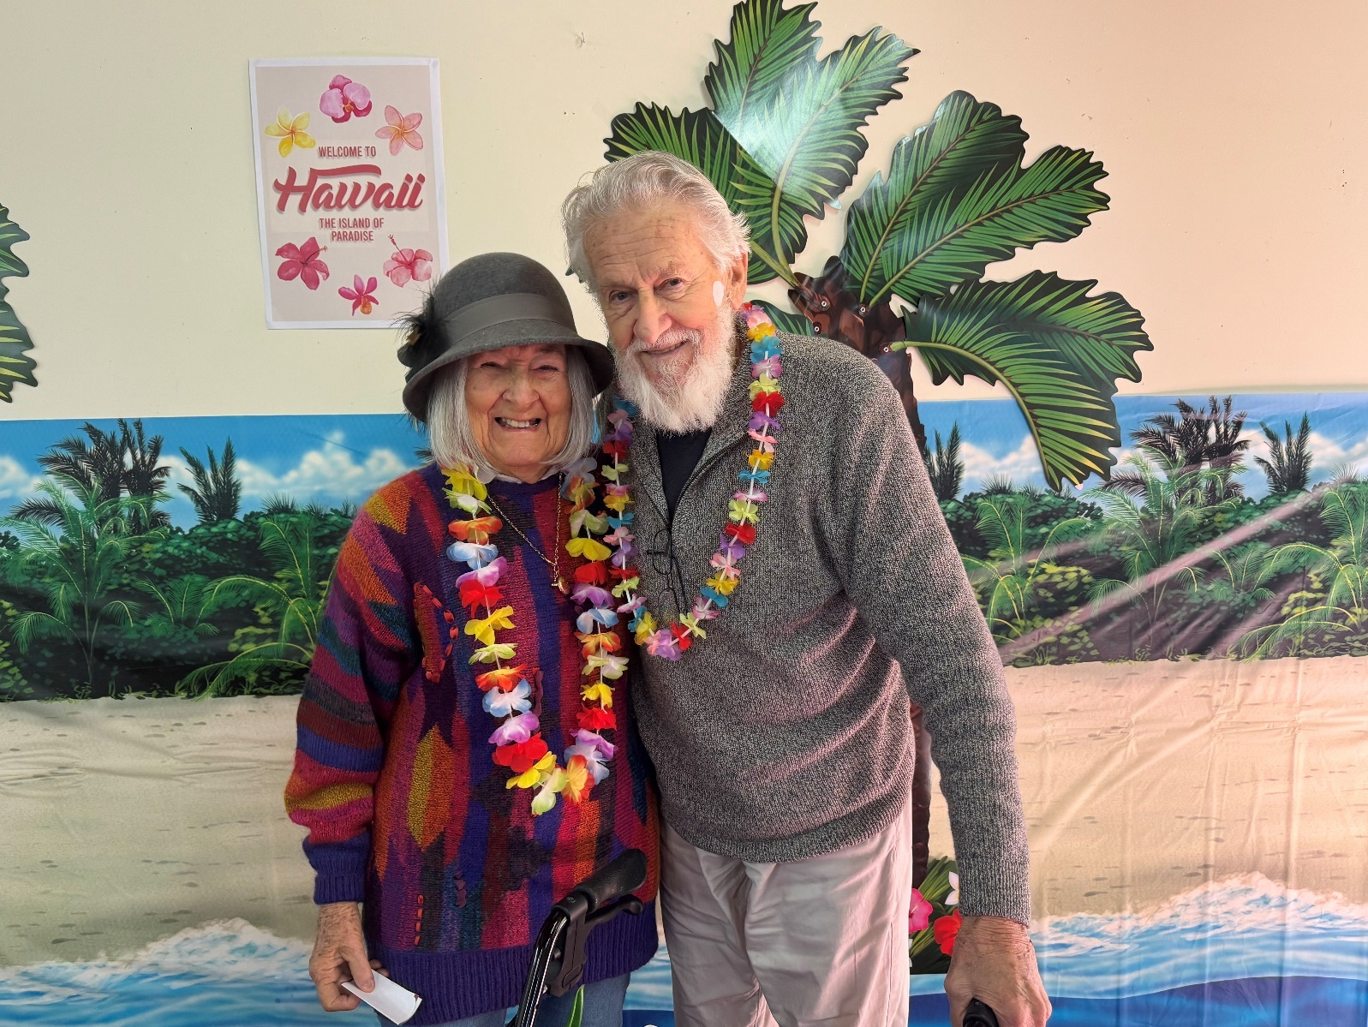

# Key Personnel within the Organisation.

General Manager Michael Powell

Care Manager Sonya Tiver

Office Coordinator Sarah Clayton

Human Resources Leanne Walker

Senior Lifestyle Coordinator Amanda Weger

Catering Supervisor Susan Bensen

Maintenance Supervisor Paul Tomlinson

Environmental Supervisor Jane Delaney

# C:\Users\wendym\AppData\Local\Microsoft\Windows\Temporary Internet Files\Content.IE5\4E9FKKEX\9551-3d-bar-graph-meeting-pv[1].jpg

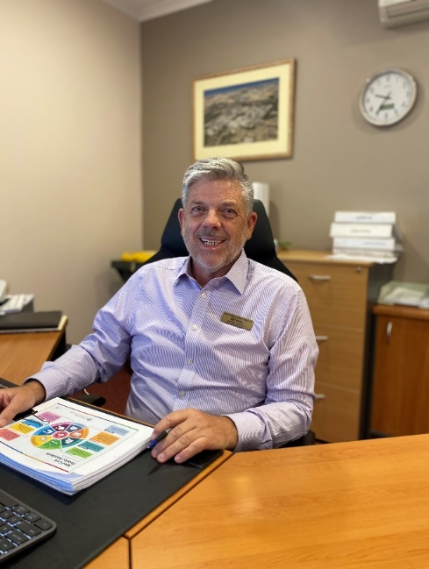Dear Residents

Welcome to the July/August edition of Pages of Parkview.

With the shortest day on June 21 now behind us, we should start to see more sunlight and hopefully some warmer days.   The frost last week was so thick on my car that it took 30 minutes to get off before I could drive to Parkview.

Last month COVID came back into the Home.  There was so much in the community that we received notices from hospitals that they were overflowing with COVID.   Parkview contained the outbreak to a bit over three weeks, and I want to thank all Residents, families, visitors and staff for your diligence in complying with our PPE program.

I would also like to thank our Residents and families for your involvement with our recent accreditation review, there were two Government auditors here for four days, who spoke with many Residents, families and staff about the care and support provided at Parkview.

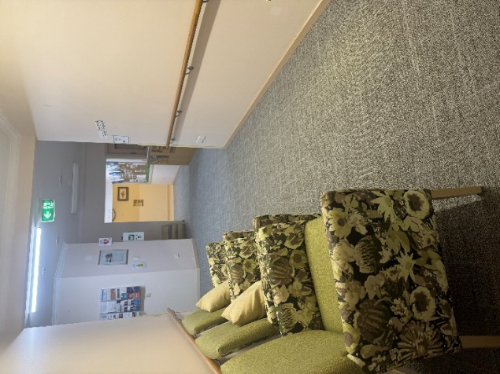At the end of each day we received a report on their findings, and in each report there were examples provided by Residents confirming the great care they receive.  It was a really affirming process and a tribute to our great staff.

We should have the report on the review provided to us in about a fortnight.

Have you seen the new floorcoverings being installed in the main office foyer and Rose Court.   It really makes the area look so large and clean…

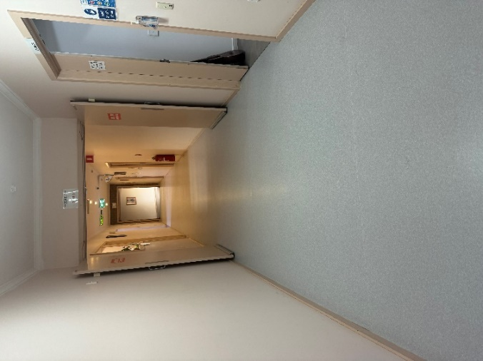Thank you for working around the flooring layers, it was a bit messy for a day or so but the results are amazing, and the painter will start on the walls next week.

I am obtaining quotes to repaint and refresh the remaining inside hallways of the entire facility which are planned to commence early August 2024.

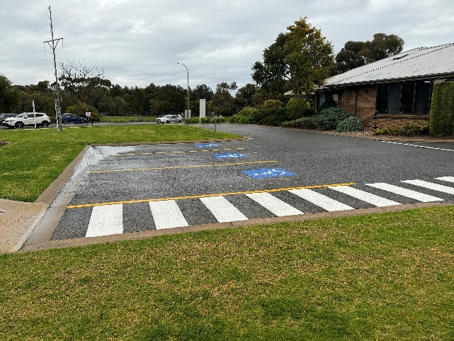We have just had our carpark lines redone, which now includes five dedicated disabled parking spaces near the front entrance.    While there is limited parking near the front entrance, I have seen Resident partners with mobility issues struggling to walk to the front entrance from their car parked on the roadway, this will now provide more spaces for them to park closer to our front door.

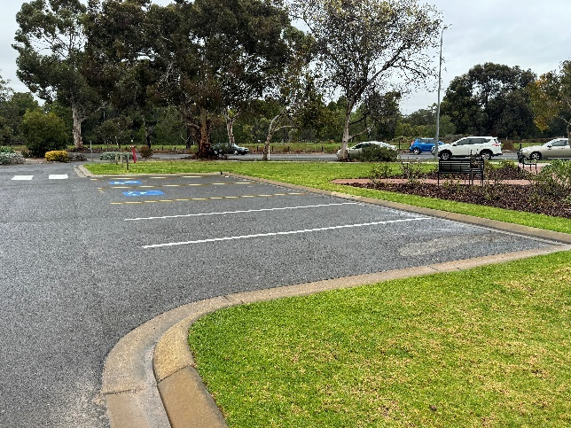Finally, please feel free to drop into my office if you have any concerns I can help you with, my door is always open and I enjoy a chat.

With kind regards

Michael

General Manager

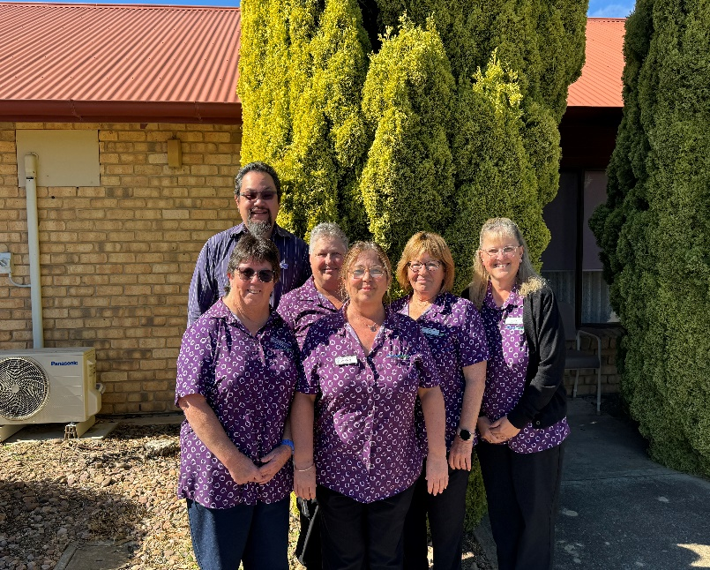Hello all,

As always, it has been a busy time in Lifestyle.

We have had changes to our activity calendar and its all about resident choices. The calendar has two activities, morning and afternoon for our residents to choose which one they would like to attend. Residents participation has increased to our activities which we are delighted to hear. The feedback we are receiving from our residents is very positive with the changes and the smiles on their faces tells us all. Recently, we have been visiting the Moonta Kindergarten, attended a Probus Meeting and going to the Uniting Church for Coffee/Chat with familiar faces our residents are seeing.

Unfortunately, we recently faced another Covid outbreak. During these times Lifestyle were giving activity packs to our residents as well as our normal activities were still going. Lifestyle are more than happy to Facetime your loved one at any time especially during these times, just let one of our Lifestyle staff know so we can arrange it for you.

We had our Mother’s Day High tea inviting one family member to spend time with their loved one. The ladies enjoyed having scrumptious cakes and all ladies received a gift from Lifestyle. We celebrated National Volunteer week with an afternoon tea for our volunteers and give a special “thank you” to all volunteers who support us, and older people to live well in our residential aged care home.

Naidoc week will be from the 7th to 14th July and we have planned some dot painting as well as having Aboriginal artefacts to show our residents with an afternoon tea. 17th July we will be celebrating Bastille Day with a luncheon followed by Arm Chair Travel to Paris ooh la la. End of July comes the Paris Olympics! Excitement is on the way to MHAACS and we will be having our own Parkview Olympic Games so checkout our facebook page for all the events happening!

That’s all from me for now, until next time.

Amanda Weger

Senior Lifestyle Coordinator

**Lifestyle Activities:**

**Mother’s Day High Tea**

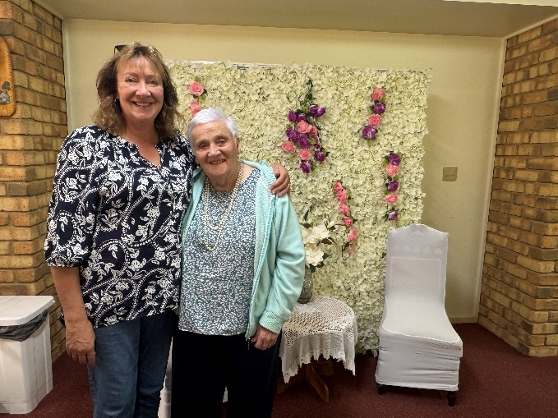

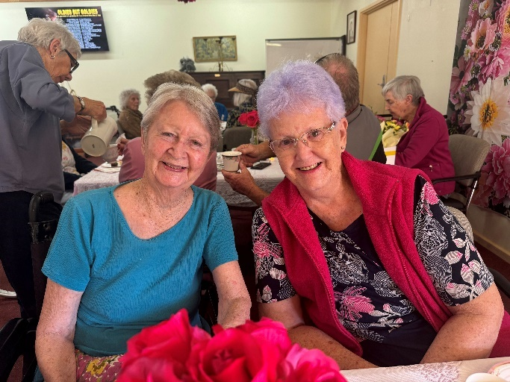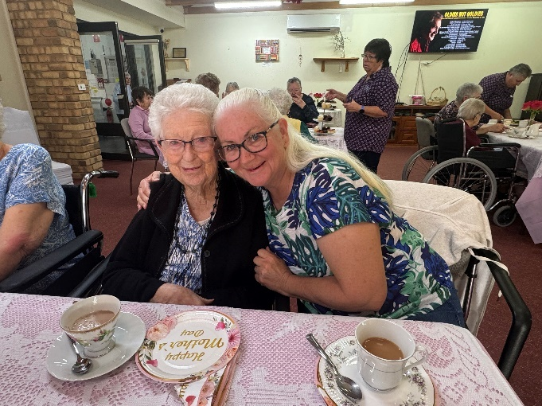

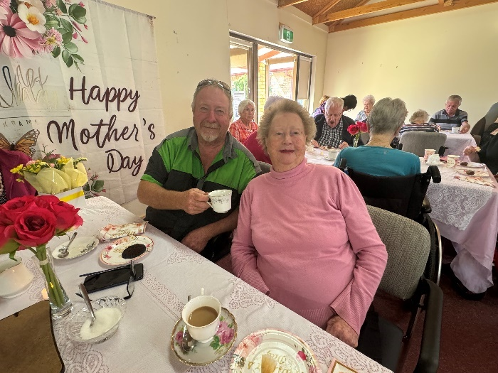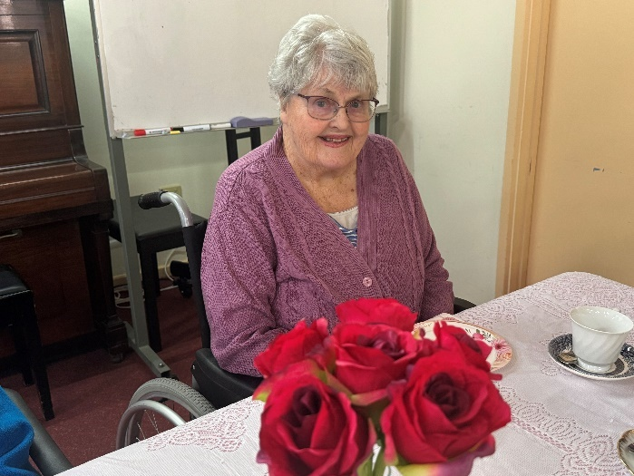

**8 Ball**

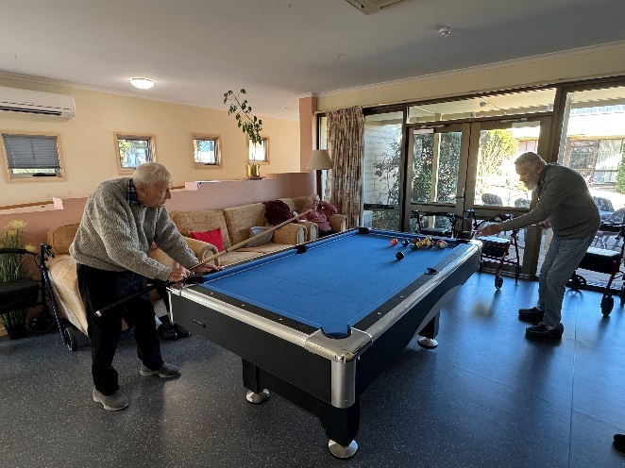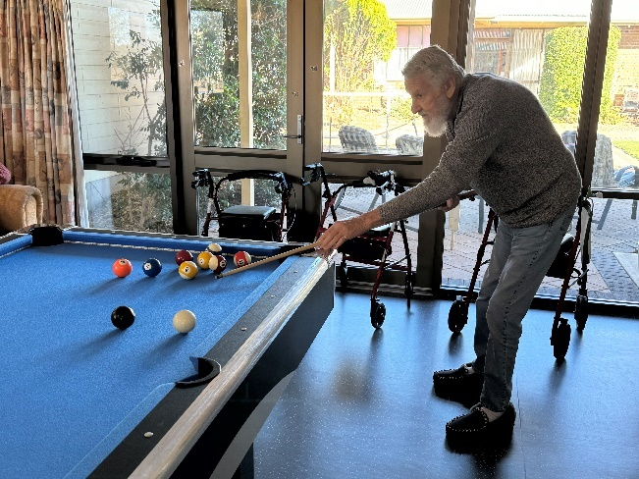

**Uniting Church Coffee/Chat**

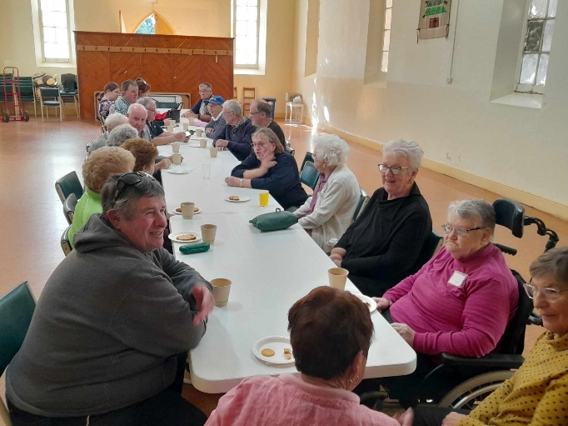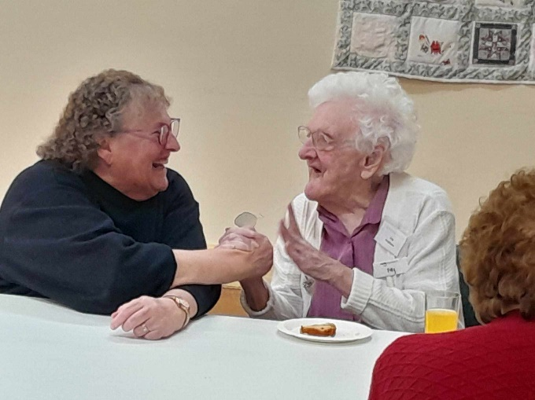

**Probus Meeting**

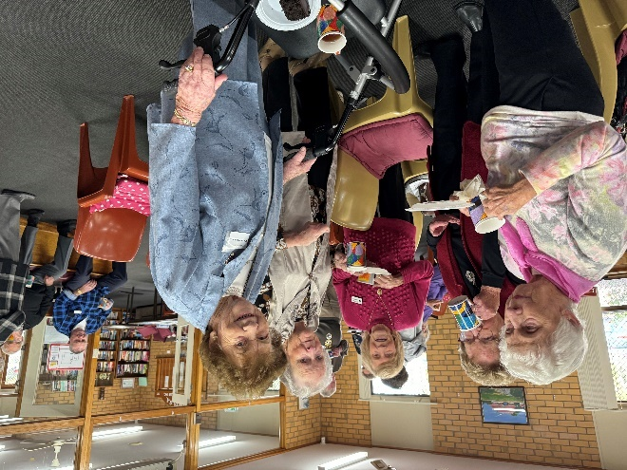 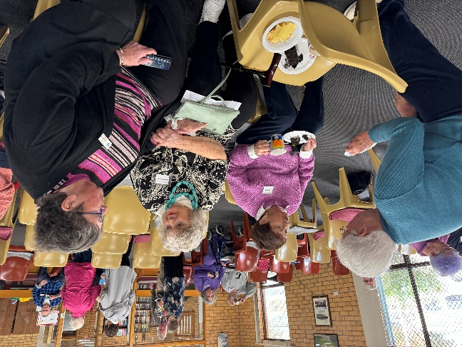

**Moonta Kindergarten Visits**

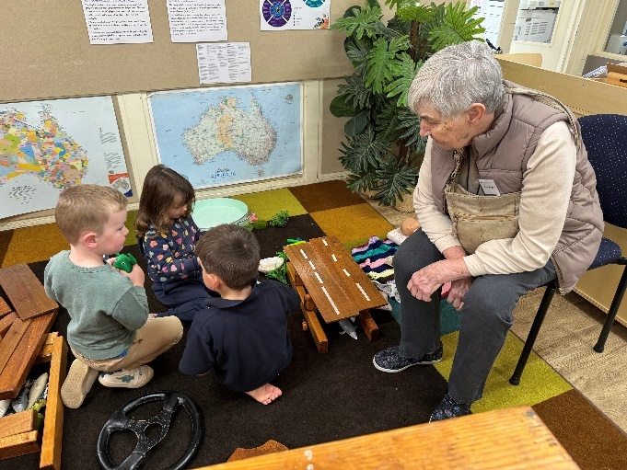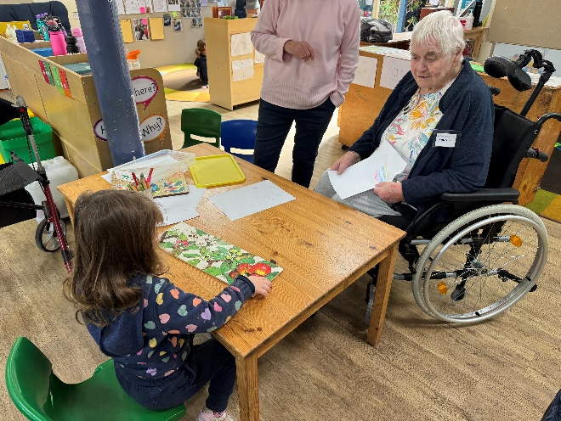

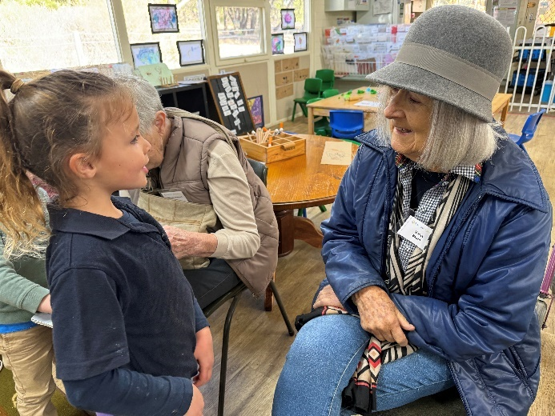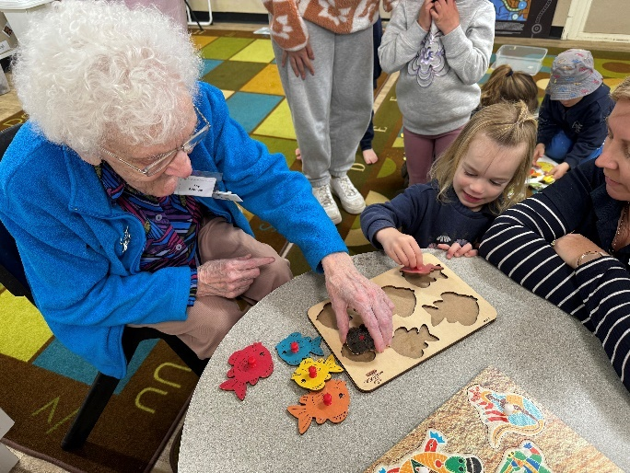

**Volunteer Appreciation Day**

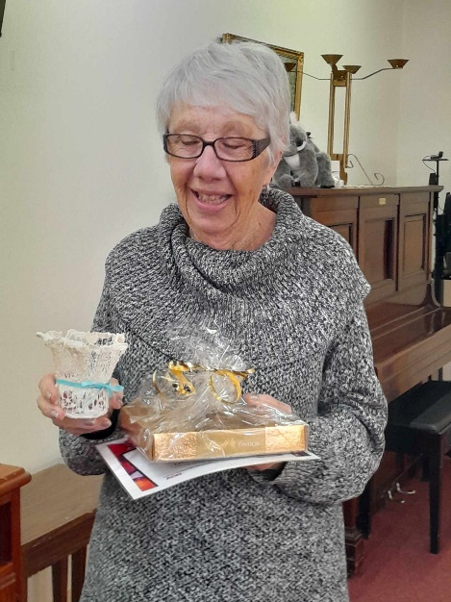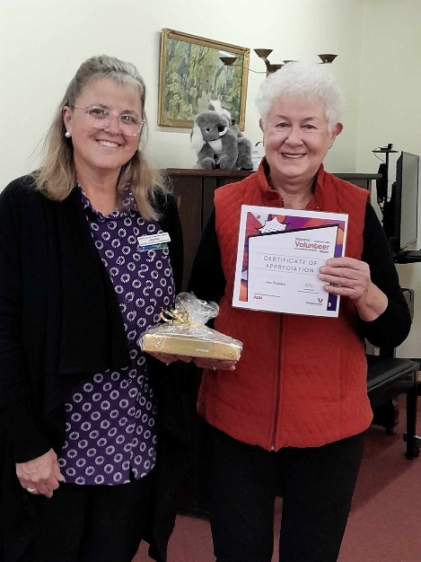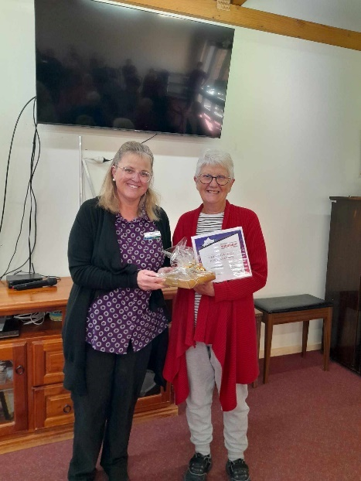

**Residents Food Connoiseurs Meeting**

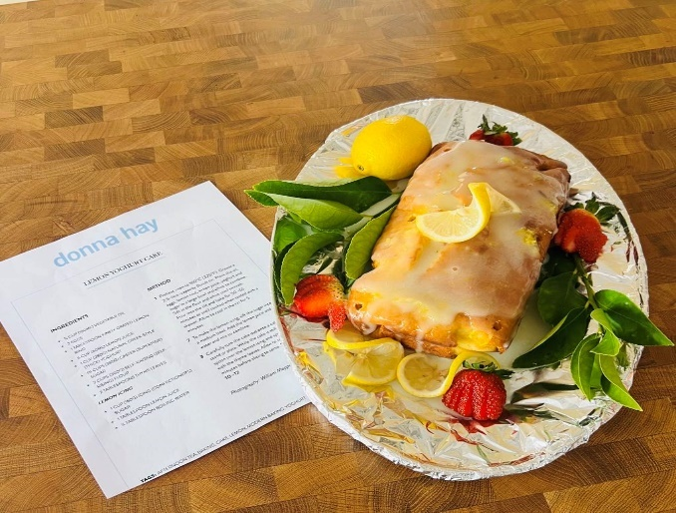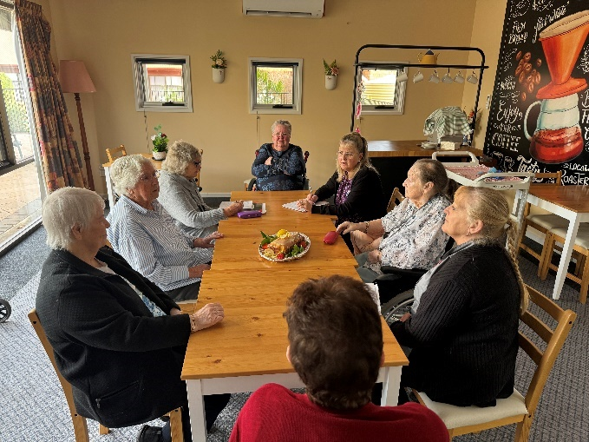

**Arm Chair Travel**

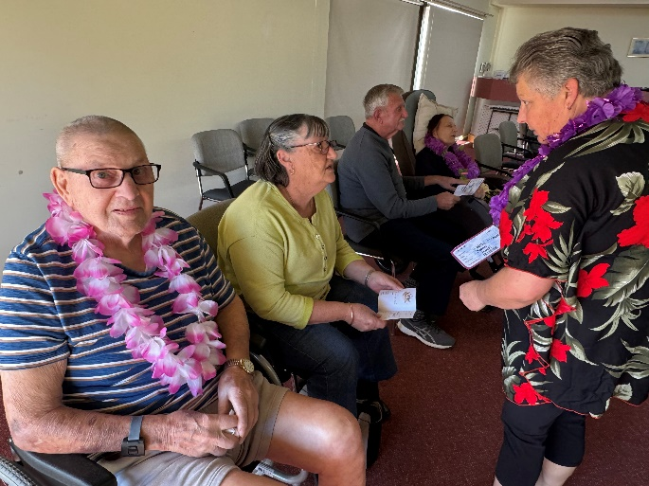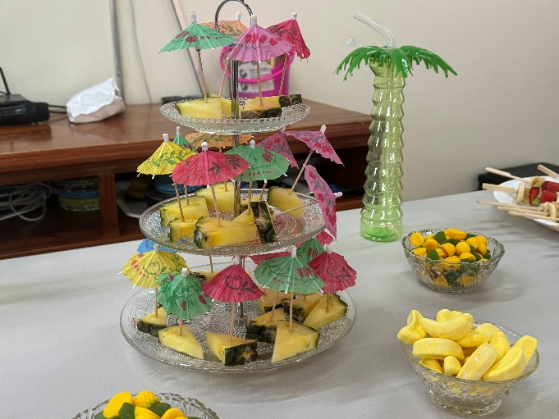

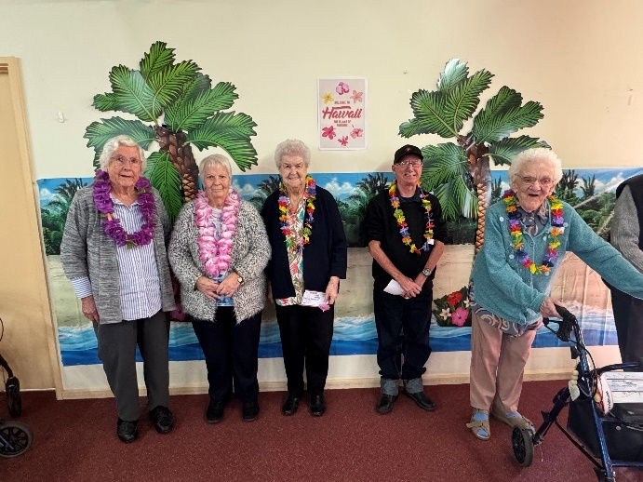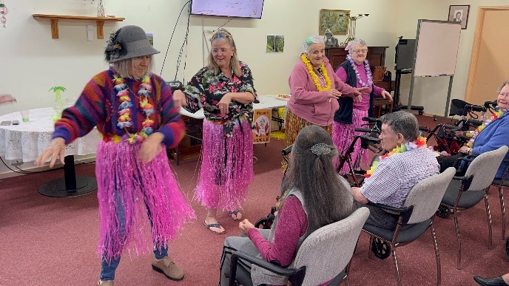



**Welcome to our new residents…**

* Sydney Myers
* Hazel Crabb
* Bruce Fleetwood
* Julie Carmichael
* Geraldine Parkin

**Gone Home….**

* Sydney Arthurs
* Janet Atkinson
* Peter Rowe

**In Memoriam…..**

Sadly we say goodbye to our much loved residents

* Geoff Lines
* Alan Morrison
* Lance Weber
* Kevin McKinlay
* Val Smith

To their family and friends may you find strength in the love of family and in the warm embrace of friends.

Caring for your loved one was a privilege.



*CELEBRATING A BIRTHDAY IN JULY 2024*

* *Beryl Elyward 2nd*
* *Bruce Fleetwood 9th*
* *Richard Witzke 9th*
* *Eileen Bunce 24th 85th*

*CELEBRATING A BIRTHDAY IN AUGUST 2024*

* *Fay Pridham 1st*
* *Nancy Beare 26th*
* *Winnie Hughes 31st*



**We are looking for consumers or consumers representative to participate to form our Quality Care Advisory Body committee. Please notify Amanda Senior Lifestyle Coordinator if you would like to come on board**.

If you have ordered newspapers or any magazines etc. for your family member please inform any of the Lifestyle staff to ensure they receive the correct order. ALL newspapers etc. are the responsibility of the family to order or cancel either through the Advertiser and our local newsagency. Remember to specify to the newsagent if the paper is required in either PARKVIEW or NURSING HOME.

**Fundraising** – a number of items need replacement over the next year.

To help us fund these we are seeking donations from our community.

Did you know as a registered Charity all monetary donations over $2 are tax deductible?

Donations can be made via cheque, or cash deposited into our bank account

BSB 105 013 AC No 035893240 Please use “Donate” as reference and ring office to request your receipt.

**Health and Safety**

**Infection Prevention:**

During the last three years, many people have become much better and more aware of the importance of good hand hygiene. We have seen the benefits, with fewer people catching colds and influenza. It is a timely reminder to keep up good hygiene practices. Infectious agents can be spread in a variety of ways, including:

• Airborne: coughs or sneezes release airborne pathogens

• Skin-to-skin contact: the transfer of some pathogens can occur through touch, or by sharing personal items, clothing or objects

• Contact with bodily fluids: pathogens in saliva, urine, faeces or blood can be passed to another person’s body via cuts or abrasions, or through the mucous membranes of the mouth/eyes

• Contaminated objects or food: the pathogens in a person’s faeces may be spread to food or other objects, if their hands are not thoroughly washed.

Standard precautions include:

• Good hygiene practices

• Frequent hand washing (including after wiping/blowing nose)

• Appropriate use of gloves (including to cover broken skin)

• Use of other personal protective equipment, such as eye protection, masks and aprons

• Safe use and disposal of sharp instruments and disposable equipment

• Correct cleaning, disinfection and sterilisation of non-disposal equipment

• Safe collection, storage and disposal of waste

• Appropriate use of cleaning agents

• Protocols for preventing and managing occupational exposures to blood or body substances.

Let’s continue to sustain good infection control practices, and keep infections at bay.

**Food Safety:**

As we age, our immune systems are less able to fight off infection, and our stomachs produce less acid, making it easier for germs to get through the digestive system. If older people do contract food poisoning, they are affected more severely by the symptoms, and take longer to recover. For these reasons, Moonta Health and Aged Care prepares and cooks food in accordance with strict food safe practices. We ask you not to bake and bring food for residents and clients.

Serving of Food and Drinks Please follow these food safety precautions:

• Wash your hands with warm soapy water before handling food and food contact surfaces, when changing gloves, after using the toilet, etc.

• Inform staff if you are feeling unwell and experiencing symptoms of food borne illnesses such as vomiting and diarrhoea.

• Do not touch food with bare hands. Use tongs, paper serviettes or wear gloves.

• Do not provide food to someone unless you know it is safe for that person. Staff will provide you with information about individual dietary requirements.

• Be aware that dietary requirements can change often for individuals. If ever unsure, please double check.

• Dietary requirements may include food allergies, diabetes or swallowing difficulties. For example, a glass of water may be harmful for some people and may need to be thickened. Others may need their food vitamised.

• Please ask the staff you work with for information regarding individual requirements.

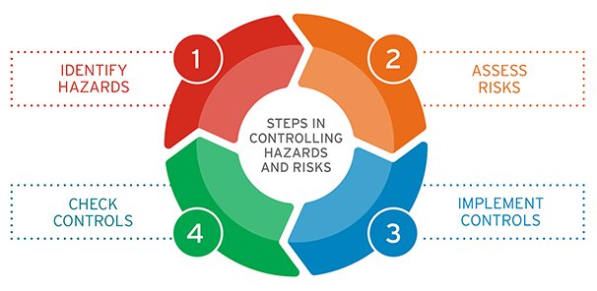**Hazard Management:**

Hazard management is a continuous process that is used to improve the health and safety of all workplaces. It is essentially a problem-solving process aimed at defining problems (identifying hazards), gathering information about them (assessing the risks) and solving them (controlling the risks). We all have a responsibility to ensure that all hazards are reported. Please speak up with your teams about any hazards you may notice. Be brave, speak up, speak out. If you don’t report it, we don’t know about it. We can’t fix it if we don’t know it’s broken. Please let your key site contact know, or report it to admin.

How we doing?

FEEDBACK

Please tell us what you think of us, Compliments or Complaints.

SUGGESTION FOR IMPROVEMENT

How Can we do better, please let us know?

**Moonta Health & Aged Care Services Facebook Page**

Come and join us, there are weekly video clips of the activities and important information to keep up with all aspects of our wonderful facility, at this stage we have 783 followers

Link:[**https://www.facebook.com/pages/category/Nonprofit-organization/Moonta-Health-Aged-Care-Service-111974350474584/**](https://www.facebook.com/pages/category/Nonprofit-organization/Moonta-Health-Aged-Care-Service-111974350474584/)

**Or search ‘Moonta Health and Aged Care” into your Facebook search bar.**



We are still looking for volunteers to assist the residents via Lifestyle department with games, bingo, cards, happy hour, newspaper reading, nail care, exercises, singalong and other activities. If you are interested, please do not hesitate to contact us as your help would be greatly appreciated. Our contact number is 8825 0000 and speak to Amanda Weger – Senior Lifestyle Coordinator. All volunteers will need to meet the infection control requirements.

[](https://www.google.com.au/url?esrc=s&q=&rct=j&sa=U&url=https://www.kindpng.com/imgv/bJmxxR_afl-football-hd-png-download/&ved=2ahUKEwiTgoLkuJn2AhW5yzgGHSeXDc4QqoUBegQIAhAB&usg=AOvVaw2dTU3aMKgnA23bRJ58J_FY)**Residents Footy tipping competition:**

Our residents footy tipping comp is going really well!

We have had a few residents get them all right. Lots of banter can be heard amongst our residents when the footy is on!

Our leader board as 8th July:

* Val Reid 93pts
* Margaret Ashton 90pts
* Peter Wurst 89pts

**MHAACS PROFILES**

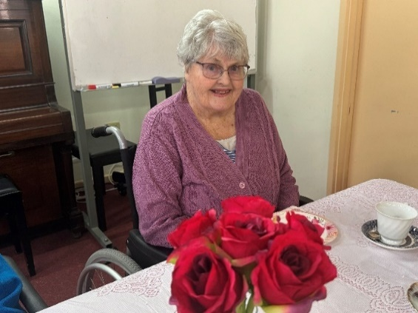

**Name –** Barbara Bagshaw **MHAACS Resident**

**Place of Birth –** Moonta SA

**Past Occupation –** Chemist-dispensary, Farmers wife

**Places I visited –** England and Australia

**Favourite Music –** I like listening to the radio and all types of music.

**People important to me –** My family and friends.

**Hobbies/Interests –** I played Golf and enjoyed the competitions.

**Thing I like –** I loved cooking Cornish pasties, pavlovas and knitting.

**Do you like living here –** Yes I do, they look after me very well.

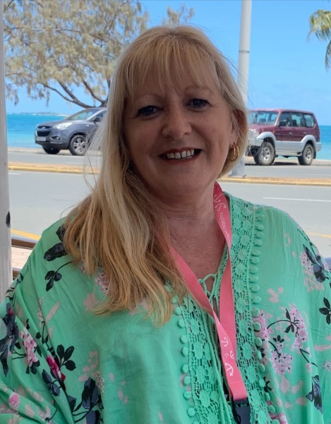

**Name:** Sue Bensen **MHAACS Staff Member**

**Place of Birth:** Wallaroo, SA

**Spouse/partner:** Husband, Mark

**Children:** Two beautiful girls Hayley & Megan

**Occupation:** Chef/Catering Supervisor

**Sport:** I played Netball, Basketball and Softball many years ago.

**Social:** I like to spend time with family and friends as well as my love of cooking and gardening.

**Holiday:** My husband and I like to cruise to the beautiful islands of the South Pacific.

**What do you like most about your job:** I enjoy my roll at MHAACS the most important part of my roll is making a difference in the lives of our Residents, it’s rewarding and fulfilling by providing our residents with Quality & delicious foods.

It’s always a pleasure listening to the residents tell their story of time gone by.

